THE ACTING OUT CYCLE

It may often seem that a child's tantrums, hitting, fighting, or other challenging behaviors come out of nowhere. In actuality, there is a cycle that children go through when they act out and this can be predictable. Sometimes, it just happens so quickly it may be hard to recognize. Understanding this cycle helps us to know how to intervene and when.
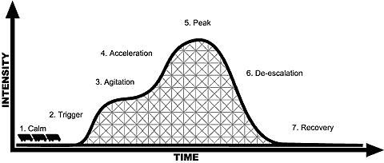

Calm: From this diagram, you can see that children start out at a Calm Phase.

Trigger: Typically something happens in the child's environment that acts as a trigger that begins the acting out cycle. (Being told to get dressed, transitioning, doing homework, etc). Other triggers being hungry, tired, having a chaotic morning at home, an argument, and so on.
*So the first strategy a parent can use is to help the child avoid or manage their triggers. Useful ideas for managing the triggers are schedules so the child knows what to expect, work time followed by fun time, and change wording of demands ie its shower time rather than do you want to have a shower.

Agitation Phase: This is the critical phase. At this point, children's emotions and behaviors begin to gain energy. If you are attuned to this phase, you may notice nail biting, hair twirling, tapping, wiggling, inability to sit still, a lack of focus, or daydreaming. Some children will clench their fists, or their jaw, making a grimace or showing frustration on their face. It is at this point when intervention by the parent is most effective and most necessary. Your goal in the agitation phase is to restore calm, otherwise the child will move into the acceleration
phase and can become out of control. It's especially important NOT to yell at the child or add to their growing tension with lecturing or reprimands.

Calming a child in the agitation phase can be as simple as moving your body close by, giving some focused attention on the child, or redirecting the child toward a different activity.

The most important thing to keep in mind is reducing the energy and restoring calm.
If at this phase, for example, the parent reprimanded or even spoke,
It could easily have pushed the child into the acceleration phase rather than restoring
calm. This is the critical time to be careful and thoughtful with your approach,
especially with children who are prone to acting out.

The most helpful way to deal with challenging behavior is to prevent it.
Paying attention to children's triggers and their agitation phase
can reduce a great deal of problems.

Acceleration Phase: This is when some parents first notice a problem, because the child increases his efforts to engage the parent - often through arguing, refusing to do what was asked, and perhaps beginning to push or kick the parents or things. Once again, our goals needs to be to cool things off and calm the child down, even if it means ignoring some of these behaviors for the time being. The worst thing a parent can do at this point is engage in a power struggle. This adds tension and intensity to the child's emotional state and will push the child right into the peak phase. Imagine the child's behavior as a run-away train. We can either help put on the brakes, or add fuel to the engine that pushes it into worse behavior.

The parent needs to stay calm -- in both tone of voice and body language. Try to use distraction, diffusion, de-escalation or redirecting the child, rather than tackling head on the behavior problem. If the parent had started to argue, or spoke, the child would have likely ramped up their own behavior into full-blown outbursts.

The hardest part of this strategy is letting go of the idea that all inappropriate behavior must be corrected, or dealt with immediately. When children are this agitated, the most important step is to cool them down so they can think and act more appropriately. The time to teach a child more appropriate behaviors is NOT when s/he is upset. When the child's anger is directed at us, this can be especially hard to do. With practice, being able to stay calm and redirect children's behavior during the Acceleration Phase will pay off in fewer severely inappropriate behaviors. You will also be more effective in teaching children appropriate behaviors to use instead.

Peak Phase: Our goal should always be prevention. However, many children move rapidly through the cycle and we might be unable to intervene quickly enough. In the Peak Phase, the child is clearly out of control, perhaps kicking, throwing his body on the floor, screaming, and so on. There is nothing that can be done to prevent the behavior at this point, so the focus needs to be on keeping the child, yourself and property safe. Think ahead of time of a plan for out-of-control behavior so that you are prepared and know how to respond. This is often the point at which parents get very stressed - even frightened of children's behavior. Practice ahead of time using breathing techniques, positive thoughts ("I can handle this"), or other self-calming behaviors. The child needs YOU to stay calm in order to regain control! Needless to say, lecturing, admonishing, yelling at, or threatening the child at this point will only prolong the behavior. Try calming techniques with the child, and if necessary, move the child to a safe place away from the rest of the children. The peak phase is usually intense but short-lived, if you don't add negative energy to it.

De-escalation Phase: As the child enters this phase, s/he will be more calm, and may withdraw or try to make amends. Just let the child de-escalate quietly. This is not a time to teach or discuss. This can last up to 90 minutes. If you intervene to early you can restart the crises phase.

Recovery: Think of the Recovery Phase as a teachable moment. It's important to review what happened with the child. Point out what might have triggered the meltdown, and make a plan with the child for how you will help her/him avoid triggers, or learn new behaviors for calming down, using words to express emotions or other needed social and emotional skills. And of course, follow up on your plan!

[Ada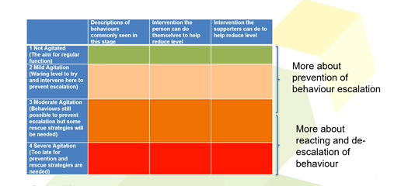pted from Addressing Disruptive and Non-compliant Behaviors: Understanding the Acting-out Cycle. IRIS Center]

