Energy Management for Teenagers
Energy Management is a tool co-created by Maja Toudal and Dr Tony Attwood to help you manage the day-to-day stress you may be experiencing as a teenager with autism.
Energy management uses an analogy of a battery to help you understand how to manage your energy levels and mood. This is a helpful example to explain the idea that everyone does things which drain and recharge their batteries. For example, your phone or ipad needs a charged battery to work well to allow you to make calls, watch YouTube or take photos. Similarly, people need a ‘charged battery’ to cope with school, meet friends and manage sensory sensitives.
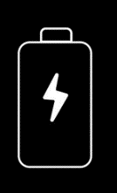
Think of your energy levels like a rechargeable battery. Everyday activities such as getting ready for school, noise or socializing with friends can ‘drain’ your battery. Sometimes even doing things you enjoy may also drain your battery. Having an ‘empty battery’ may be causing you high stress levels and feelings of anxiety.
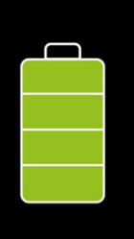
There may be things in your life that re-charge your battery. Some examples may be time spent on your special interest, listening to music, or exercise. Having a ‘recharged battery’ may help you feel calm and relaxed.

Energy Management is a useful way to help you keep track of the balance between activities that drain and recharge your battery. The idea is that when activities drain your battery, you need to make time for activities that recharge it. This will help avoid the physical and mental health problems that can result from an energy depletion or empty battery.
How it works:
- Make a list of all the activities and tasks that drain you of energy. Value each of these out of 10 by how much they drain you of energy. 1 is a little and 10 is a lot.
- Make a list of all the things that you find relaxing, that calm you down, and make you feel better afterwards. Value you each one of these things out of ten by how much they make you feel better and recharge your battery. 1 is a little and 10 is a lot.
- Look at your daily schedule and try to ensure that you have enough re-charging activities to counteract the tasks that drain your energy.

Example of Energy Management:
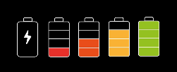
Each person’s list of draining and recharging activities will be different. Here is an example of things that you might find to be an energy drain or an energy recharger. Please add some of your own to the list.
Draining | Recharging
Meeting up with friends | Being on your own
Change | Favourite interest
Making a mistake | Exercise
Sensory Sensitivity | Stroking your dog
Cleaning your room | Computer games
Other people being in a bad mood | Meditation or mindfulness
Being teased or bullied | Sleep
Going on a public bus | Eating a bag of crisps
Non-uniform day | A cup of tea/coffee
Things that recharge my battery
Things that use up my energy

